ABSTRACT

Reading has always instilled ideas in the heads of creative people and developed into new inventions, from the "Earth" program in Neil Stephenson's novel "The Avalanche", from which the "Google Earth" application was inspired .

Of course, the importance of reading is not the subject of the document. We all understand the importance of reading, and our project is very important for everyone who reads because it will simply change the concept of regular reading and will help extract important information in more than one form and will help to understand the texts better and thus get many inspirational ideas .

We provide three services through our App :

1-Automatically generating mind maps out of pure text and that requires many stages of text processing

2-Automatically generating summary is a shortened version of a text. It contains the main points in the text

3-Automatically generating Word cloud A word cloud is a collection, or cluster, of words depicted in different sizes. The bigger and bolder the word appears, the more often it’s mentioned within a given text and the more important it is .

And in order to be able to achieve all of this we are focusing on Natural Language Processing, or NLP for short, is broadly defined as the automatic manipulation of natural language, like speech and text by software and of course we will using python .

1-INTRODUCTION

When a Falcon rocket blasted into space in February 2018, it was carrying an unexpected payload. Unlike the red "Tesla Roadstar" car and the doll in the astronaut suit behind the steering wheel, SpaceX founder Elon Musk put in the front glove box of the car the "foundation" series of novels by Isaac Asimov recorded on an optical disk. Its events took place in a future era after nearly 50,000 years, igniting his passion for space travel as a teenager. It has now been flying in space around our solar system for about 10 million years or more.

Reading has always instilled ideas in the heads of creative people and developed into new inventions, from the "Earth" program in Neil Stephenson's novel "The Avalanche", from which the "Google Earth" application was inspired, to phones that have the ability to sense in Arthur C. Clarks' novel, which She led Tim Berners-Lee to invent the World Wide Web. Barack Obama says that reading helped him get to know himself and shaped his beliefs.

I have mentioned all these examples to demonstrate the importance of reading and that it was the first inspiration for all the great people who changed the course of history.

***The question now is what is the relationship of all this to our project?***

Our project aims to launch many services that facilitate the task of reading, and we can mention, for example, the word cloud, the mind map, and the summary of texts. All these services will help attract many readers and help them to reach the purpose of every article, report or scientific content that they read easily and Without effort, our project will help many creative people to continue achievements, change the concept of reading for some, and continue working until reading becomes an enjoyable activity.

2- Domain model

Mind mapping is a popular brainstorming tool and thinking technique of visually arranging ideas and their interconnections. It is a way of representing related thoughts with symbols rather than with inessential words. The human mind forms associations almost promptly, and "mapping" allows capturing these ideas quicker than expressing them using only words or phrases. Originated in the late 1960s by Tony Buzan (1). It is now used by millions of people around the world.

Manually creating mind maps requires comprehensive reading and good understanding the text which takes much time and effort. In addition to that not all people are inventive enough to draw elegant and meaningful mind maps.

Therefore, automatically generating mind maps spares much time and exertion and serves way better and speedier several applications .

The applications that make the mind map is Xmind , FreeMind, Edraw MindMap, and MindMeister.

But this applications are manual, because the user manually determines the mind map element These softwares help the user in drawing the mind map and have some ready designs and diagrams which can be used. But the user must read, understand the text well and come up with a design for the mind map himself.

We provide Automatically generating mind maps out of pure text and that requires many stages of text processing.

* **Related works**

## M2Gen In 2009 (2)

The concept of M2Gen is to generate the Mind Map object from semantic model taken from a given text. The English text is transformed into a semantic model or meaning representation using numerous natural language understanding tools such as morphological analysis, parsing and Semantic Analyzer. The complete procedure is shown in Figure 1.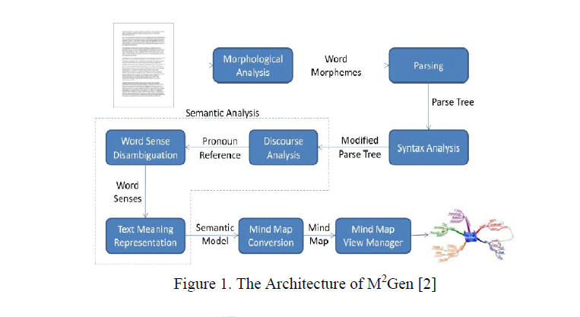

First, the English text is processed by morphological analysis in order to analyze each word into its lemma and affix along with its POS tag. The result of morphological analysis is then processed by parsing component by using CFG and top down chart parsing. Since not all parts of parse tree are used, then there is a parse tree alteration process in the syntax analysis. The result is then used by semantic analysis to produce the semantic model. The semantic analysis contains of several sub components such as discourse analysis, word sense disambiguation and text meaning representation. The discourse analysis aims to solve the pronoun reference in sentences .

The word sense disambiguation aims to select the best sense of a single word, and the text meaning representation aims to transform the parse tree result into the semantic model. The resulted semantic model is then converted into Mind Map figure. The example of generated Mind Map figure is shown in Figure 2.

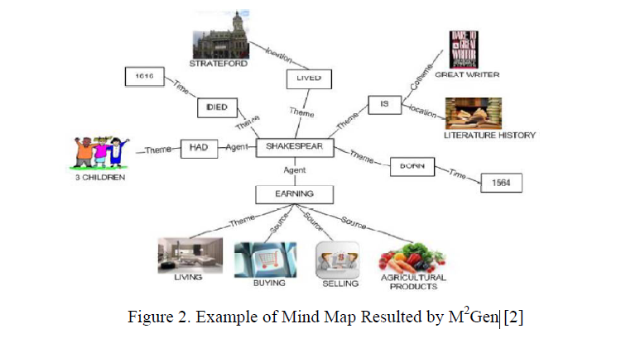

On the other hand :

* this version only supports single layer mind map and does not produce a hierarchical (multilevel)
* the images assigned to the nodes are not accurately representing them

## Generating Mind Map from Indonesian Text using Natural Language Processing (3)

This make the process easier by generating mind map from text (here is Indonesian text) and providing mind map editor to manipulate the object and relation set.

To build such tool, They utilize obtainable Indonesian NLP (Natural Language Processing) tools.

There are three constituents needed: semantic net generator, mind map visualization and interaction handler. In the semantic net generator, the resulted first order logic (FOL) resulted by the semantic analyzer is changed into semantic net which is represented by roll of objects and roll of relations. The resulted semantic net is then imagined by using combination method of radial and layering drawing. The interaction is obtainable for editing the object and the relation. The tool was then assessed by 2 experiment set: testing the semantic net generation and testing the resulted imagining.

The semantic net generation was assessed by using the valid input text, while the visualization was assessed by user acceptance test.

As the result, although the semantic net generation (from FOL) is an acceptable one, but the whole semantic analyzer for Indonesian text still has a soft accuracy specifically for composite sentence. As for the user acceptance test, the automatic generation still gives inconsequential object which should be altered by the interaction.

## Generating mind map from an article using machine learning (4)

Data Collection: The data used in this study contains of two types, namely:

a. Article: article contains of numerous paragraphs, data in given to the expert for validation.

b. Validation Results: articles that have been stamped topic sentence in each paragraph.

Model design: At this stage there are several things that are improved that is Information Retrieval Approach where in it there is a pre-processing text procedure, Core NLP, Part of Speech Tagger. At the procedure of text processing technique used is segmentation, tokenization. Data is processed to distinct sentences into words per word text pre-processing, then done core NLP and part of speech tagger to determine the word type per word in the sentence. There are three types of words specified, among others, Noun, Verb, and Adjective. The following handle is the highlight extraction in which there's a prepare: frequency, sentence position value, and similarity with title and sub-title. After that, sentence scoring is done to sum up the value obtained from the feature extraction. Then the last phase is the sentence ranking and summary extraction after the calculation is done it will be selected the highest value to be the topic sentence of the paragraph .

Testing is done by contrasting the concept map of automatic generation with concept map made by experts , The results showed 52.5% accuracy the accuracy of the system is average.

References

1-

<https://mindmappinggallery.blogspot.com/2010/09/who-is-tony-buzan.html>

2-

(M. Abdeen, R. El-Sahan, A. Ismaeil, S. El-Harouny, M. Shalaby)

The Faculty of Computers and Information Sciences | Ain-Shams University Cairo, Egypt.

<https://www.researchgate.net/publication/224129737_Direct_automatic_generation_of_mind_maps_from_text_with_M2Gen>

3-

Generating Mind Map from Indonesian Text using Natural Language Processing (Athia Saelan, Ayu Purwarianti) in 2013

<https://www.researchgate.net/publication/270916540_Generating_Mind_Map_from_Indonesian_Text_Using_Natural_Language_Processing_Tools>

4-

Generating mind map from an article using machine learning: Nurrokhim in 2019

<https://iopscience.iop.org/article/10.1088/1742-6596/1280/3/032023>